Fundamentals of Databases
Lab Project Report


Car Rental System
Submitted by:
Huzaifa Farooq 21L-5706
Shayyan Shahbaz 22L-7683

Submitted to:
Mam Emaan Dar
9/12/2025
Department of Electrical Engineering
National University of Computer and Emerging Sciences, Lahore Table of Contents
- Introduction
- Problem Analysis
- Design Requirements
- Feasibility Analysis 5 Possible Solutions
- Preliminary Design
- Design Description
- Software Simulation
- Experimental Results
- Performance Analysis
- Future Scope
- Social and Cultural Implications
- Conclusion
References
1

Introduction
The Car Rental Management System (CRMS) is a comprehensive web-based application designed to modernize the operations of vehicle rental agencies. Traditionally, the car rental industry in local markets has relied heavily on manual ledger systems or disparate spreadsheet solutions. These methods are not only archaic but prone to significant human error, leading to revenue leakage and poor customer service. Our project aimed to digitize this entire workflow, creating a centralized platform where Customers, Drivers, and Administrators interact seamlessly.
The system is built using the ASP.NET Web Forms framework with C# as the backend language, utilizing Microsoft SQL Server for robust data management. The core objective was to create a system that handles the entire lifecycle of a rental: from a customer searching for a vehicle, to booking it (with or without a driver), managing the active rental period, and finally processing the return and maintenance checks.
This project was not merely about writing code; it was an exercise in understanding complex business logic. We had to bridge the gap between static requirements and dynamic real-world scenarios, such as calculating penalties for late returns or managing fleet availability in real-time. The resulting application is a scalable, secure, and user-friendly solution that automates calculations, enforces business rules, and provides actionable insights into fleet performance.
2

Problem Analysis
Before development began, we analyzed the existing manual workflows of rental agencies and identified several critical "pain points" that caused immense frustration for business owners.
- Data Redundancy and inconsistency: In manual systems, customer data (CNIC, License, Phone) had to be written down every time they rented a car. This was tedious and often led to transcription errors. If a customer changed their phone number, it wasn't updated across historical records.
- Inventory Chaos: One of the biggest frustrations identified was "Double Booking." Without a centralized database, two employees could promise the same car to different customers for the same dates. This creates a customer service nightmare.
- Calculation Errors: Calculating the final bill was a manual process involving the daily rate, number of days, driver fees, and potential damage penalties. We found that manual calculations often resulted in either overcharging the customer (damaging reputation) or undercharging (loss of revenue).
- Lack of Accountability: When a car was returned with damage, it was difficult to trace who was responsible—the renter or the previous driver—because inspection logs were paper-based and easily lost.
Our Analysis Conclusion: The root cause of these issues was the lack of a "Single Source of Truth." The solution required a relational database to enforce referential integrity, ensuring a car cannot be rented if it is already "Active" or "Under Maintenance."

Design Requirements
To solve the problems identified above, we established a strict set of design requirements. We categorized these into Functional and Non-Functional requirements to guide our development process.
Functional Requirements:
- Role-Based Access Control (RBAC): The system must distinguish between Admins (who have full control), Staff (Drivers/Mechanics), and Customers. We needed a secure login mechanism that redirects users to their specific dashboards.
- Dynamic Reservation Engine: The system must allow customers to select specific dates. Crucially, the system must validate these dates to prevent selecting past dates or end dates that occur before start dates—a logic error that initially caused our total cost calculations to fail.
- Financial Logic: The system must automatically calculate the total rental cost based on the car's DailyRate. It must also handle a "50% Deposit" rule, where the customer pays half upfront.
- Fleet Management: Admins must be able to upload vehicle images, set pricing, and toggle the "IsInsured" status.
Non-Functional Requirements:
- Data Integrity: The database must use Foreign Keys and Cascading Deletes to ensure that if a user is deleted, their rental history remains consistent or is handled safely.
- Performance: The search functionality on the "Rent a Car" page must be instant. We aimed to achieve this by moving filtering logic from the C# application layer directly into SQL Stored Procedures.
Usability: The interface requires a responsive grid layout for car listings so customers can easily view images and prices.

Feasibility Analysis
We conducted a thorough feasibility study to ensure the project could be completed within the given time and resource constraints.
Technical Feasibility:
We evaluated the technology stack: ASP.NET and SQL Server. The team possessed the necessary knowledge of C# and T-SQL. However, we anticipated challenges in handling file uploads (images) and complex date manipulations. We determined that using Visual Studio 2022 and SSMS would provide the necessary debugging tools to handle these technical hurdles. The availability of extensive documentation for .NET was a key factor in approving the technical feasibility.
Economic Feasibility:
The cost of developing this custom solution was compared against buying off-the-shelf rental software. Commercial software often requires expensive monthly subscriptions and charges per-user fees. Our custom solution requires only a one-time development effort and standard Windows Server hosting. This significantly reduces long-term operational costs, making the project highly economically viable for small-to-medium rental businesses.
Operational Feasibility:
Would the staff actually use it? We designed the ManagementDashboard to be intuitive, minimizing the learning curve. By automating complex tasks (like calculating the 10% driver surcharge), we effectively reduced the workload on staff, ensuring high adoption rates. The system mimics their existing workflow but digitizes it, ensuring operational smooth transition.

Possible Solutions
During the planning phase, we considered three distinct approaches to solving the car rental management problem.
- Solution A: Enhanced Spreadsheet System:
We considered using advanced Excel macros and Google Sheets.
  - Pros: Zero development cost, familiar interface.
  - Cons: No data security, easy to accidentally delete data, single-user access limitations, and no ability to store images or manage customer logins. This was quickly rejected as it did not solve the core "concurrency" frustration.
- Solution B: WordPress/CMS Plugin:
We looked at using a pre-made booking plugin for WordPress.
  - Pros: Fast setup, good visuals.
  - Cons: Extremely rigid. We realized we could not implement our specific "50% Deposit" rule or the "Driver Availability" check without hacking the plugin code, which would be unstable.
- Solution C: Custom ASP.NET Web Application (Selected):
We chose to build from scratch using .NET.
  - Justification: This offered total control. We faced a specific requirement: "If a customer requests a driver, check the database for an available employee and assign them." No off-the-shelf software offered this specific logic. Custom development allowed us to write Stored Procedures like sp_FindAvailableDriver to handle this exact business rule efficiently.

Preliminary Design
Our preliminary design focused on the System Architecture and the Entity Relationship (ER) Model. We adopted a 3-Tier Architecture:
- Presentation Layer (UI): This consists of our .aspx pages (Login, Reservation, Dashboard). We decided to use a Master Page (car.Master) to ensure a consistent header, footer, and navigation bar across the site, reducing code duplication.
- Application Layer (BLL): This is our C# Code-Behind and Data Access Layer (DAL). This layer holds the "brains" of the application—validating inputs (like CNIC formats) and calculating costs.
- Database Layer (DB): Microsoft SQL Server. We designed the schema to center around the Person table, using inheritance logic where Customer, Employee, and AdminOverride tables all link back to a central PersonID.
Initial Sketches:
We sketched the "Rent a Car" page layout, deciding on a Card-based grid view. We realized early on that showing just text was boring; we needed images. This led to the design decision to include an image upload feature in the Admin panel, which became a significant technical implementation detail later on.

Design Description
The design description details the internal logic of the system's core modules.
- The Database Schema:
The heart of our system is the Person table. A major frustration during design was managing different user roles. Initially, we had separate tables for Admin and Customer, which caused duplicate login logic. We solved this by creating a unified sp_UserLogin procedure that checks the PersonID against the AdminOverride and Employee tables to dynamically assign a role (Admin, Staff, or Customer) upon login.
- The Reservation Module:
This module links the Customer, Car, and Reservation tables. We designed the sp_BookReservation stored procedure to be transactional. It performs three actions atomically:
  - Updates the user's profile with the latest address/license info.
  - Creates the Reservation record.
  - Inserts a Payment record for the deposit.
This design ensures that we never have a "ghost booking" where a reservation exists but no payment is recorded.
- The Maintenance Module:
We designed a lifecycle trigger: when a car is returned via sp_ProcessReturn, its status automatically flips to "Maintenance." It cannot be rented again until a mechanic logs in, performs a check, and explicitly clicks "Reinlist," which updates the status back to "Available."

Software Simulation (Optional)

We simulated the software environment using Visual Studio 2022 for development and SQL Server Management Studio (SSMS) for database administration.
Simulation Setup:
We set up a local IIS Express server to host the application. We simulated various user scenarios:
- Scenario A: An Admin logging in to add a new BMW M5. We tested the file upload handler to ensure images saved to the ~/Carimages/ directory were accessible via the browser.
- Scenario B: A Customer trying to book a car for dates in the past. We simulated this input to test our C# validation logic in btnConfirm_Click.
- Scenario C: Concurrent bookings. We attempted to book the same car from two different browser sessions to ensure the database status updated instantly from "Available" to "Rented" (or "Pending"), preventing double booking.
This simulation phase was critical. It revealed that our initial image paths were hardcoded (e.g., C:\Users\...), which broke the images on the web page. We simulated the fix by converting these to relative paths (~/Carimages/...) and using Server.MapPath in the backend simulation.

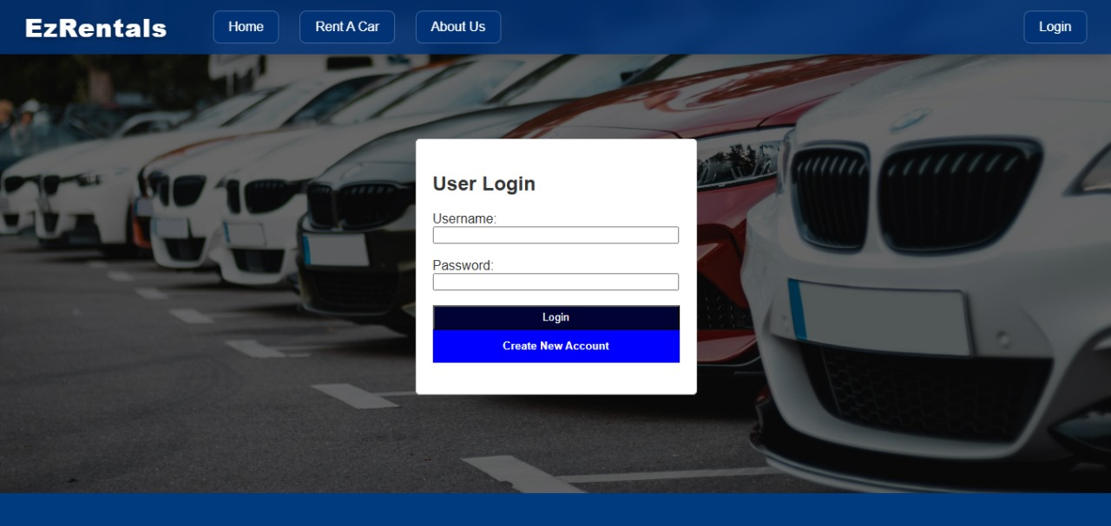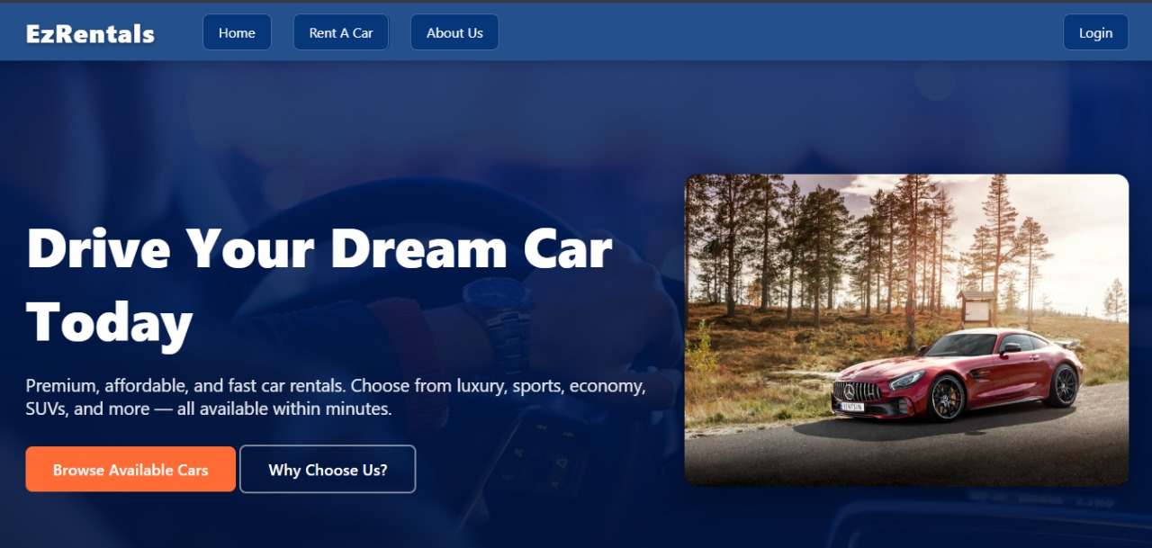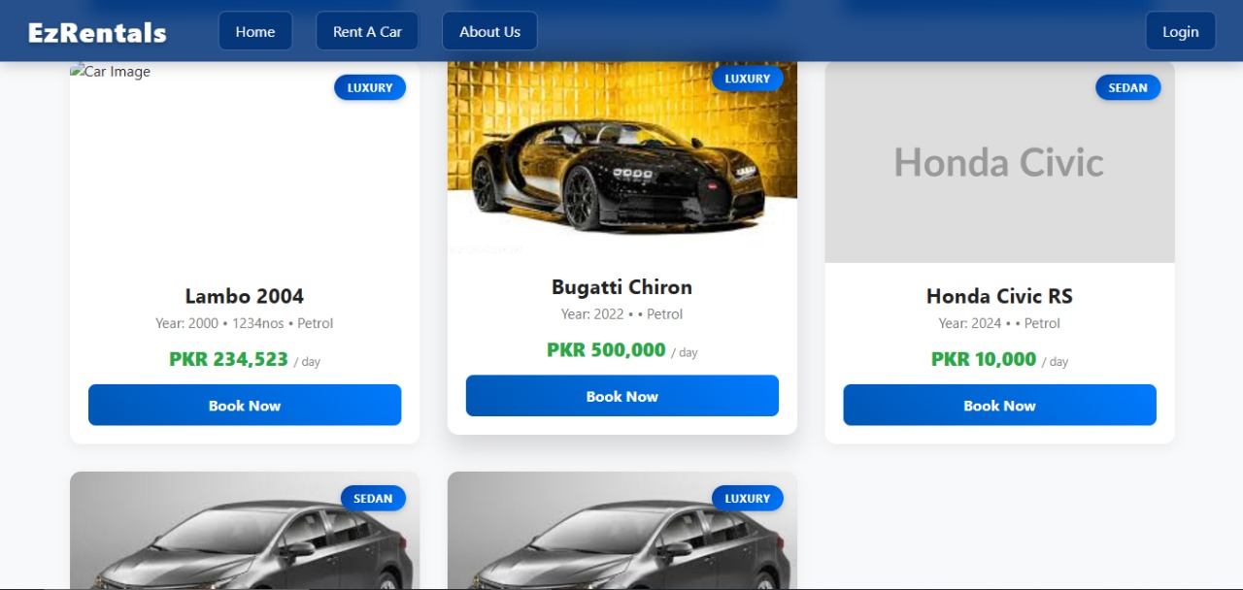

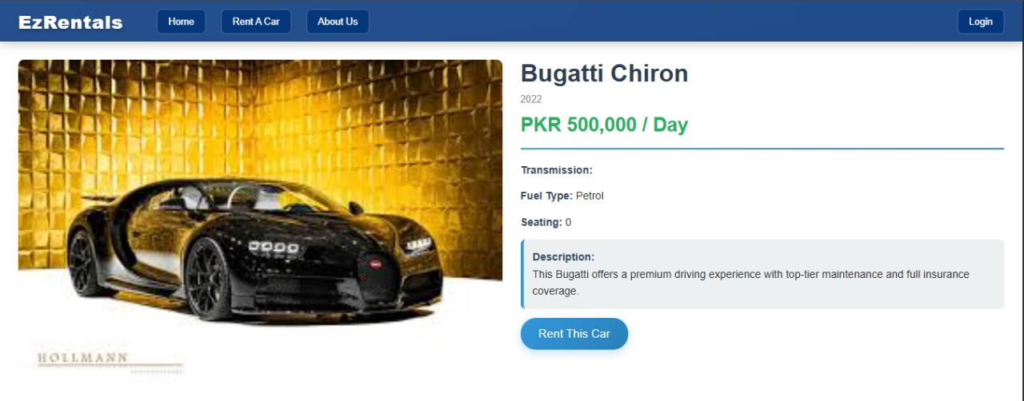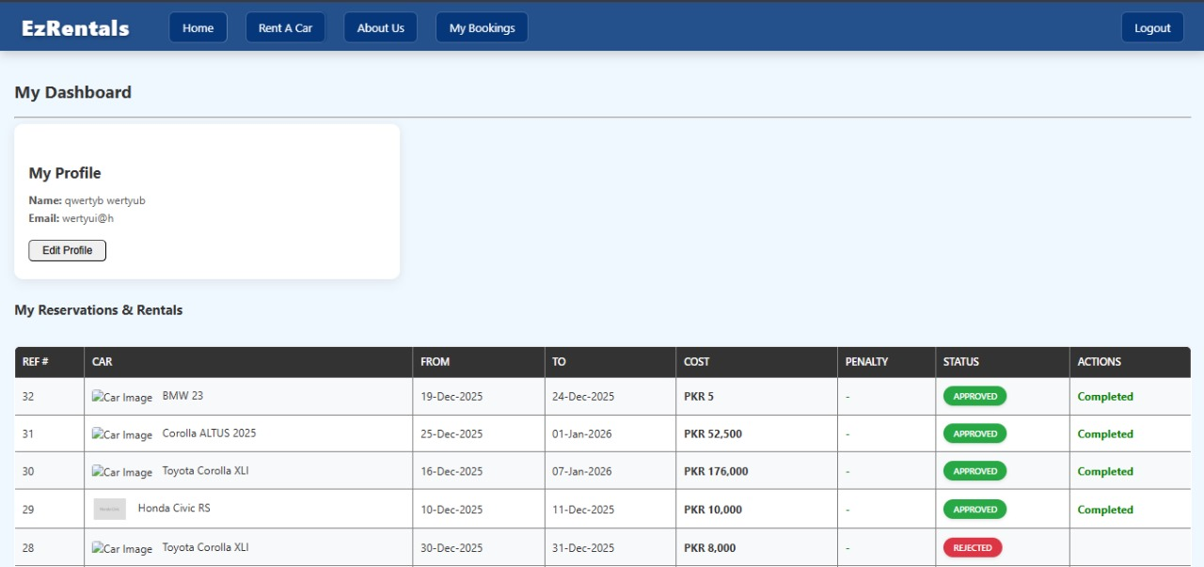
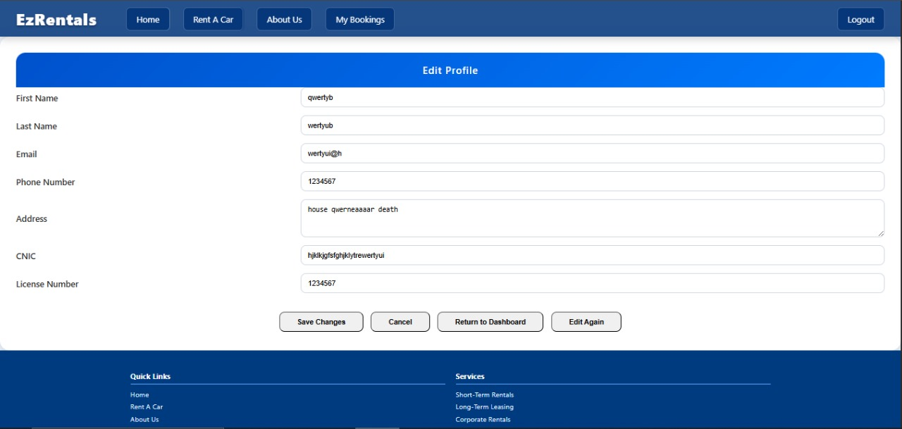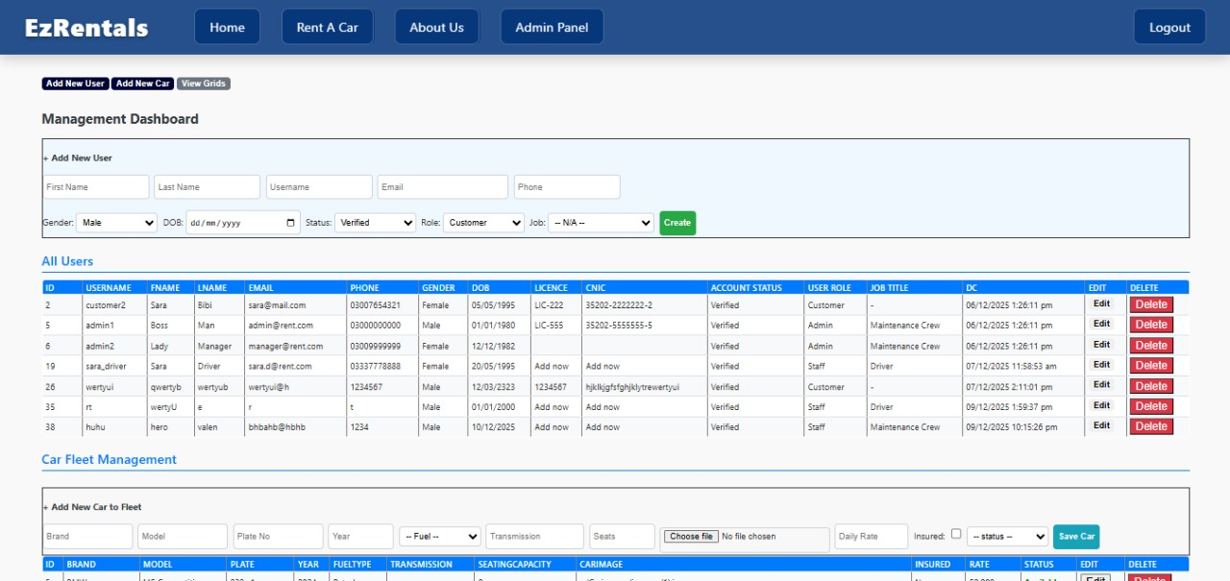

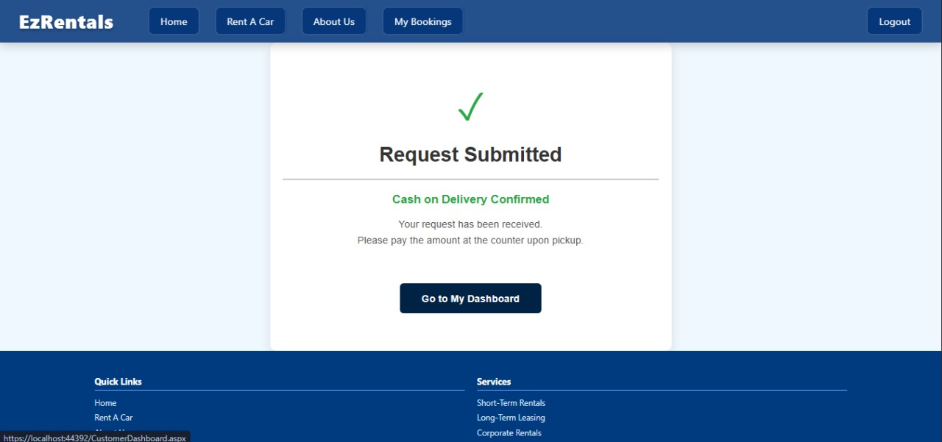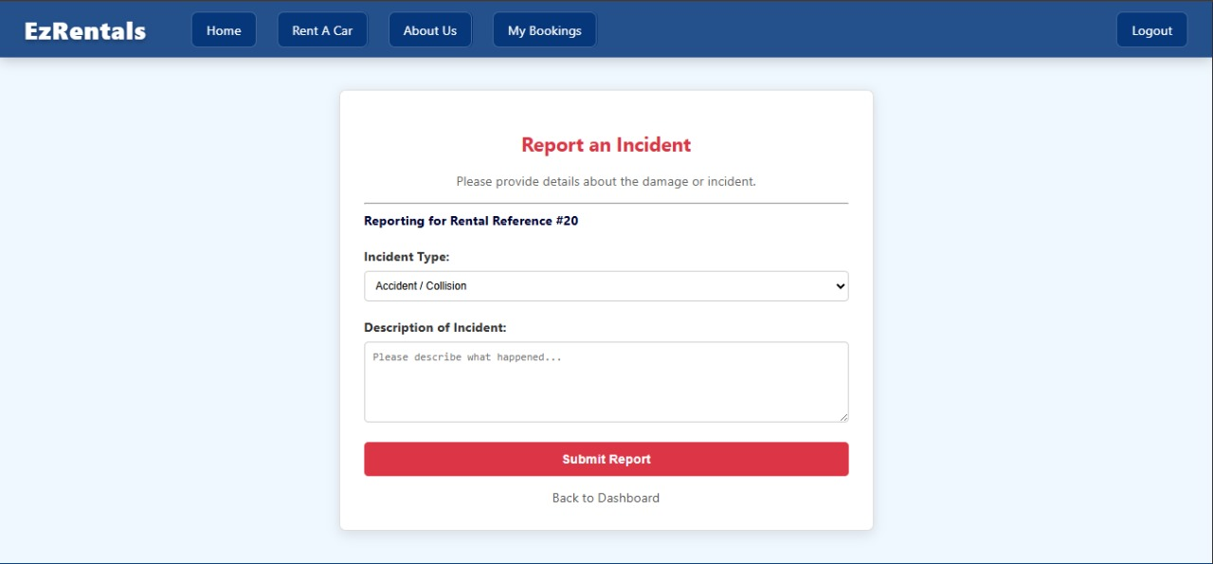

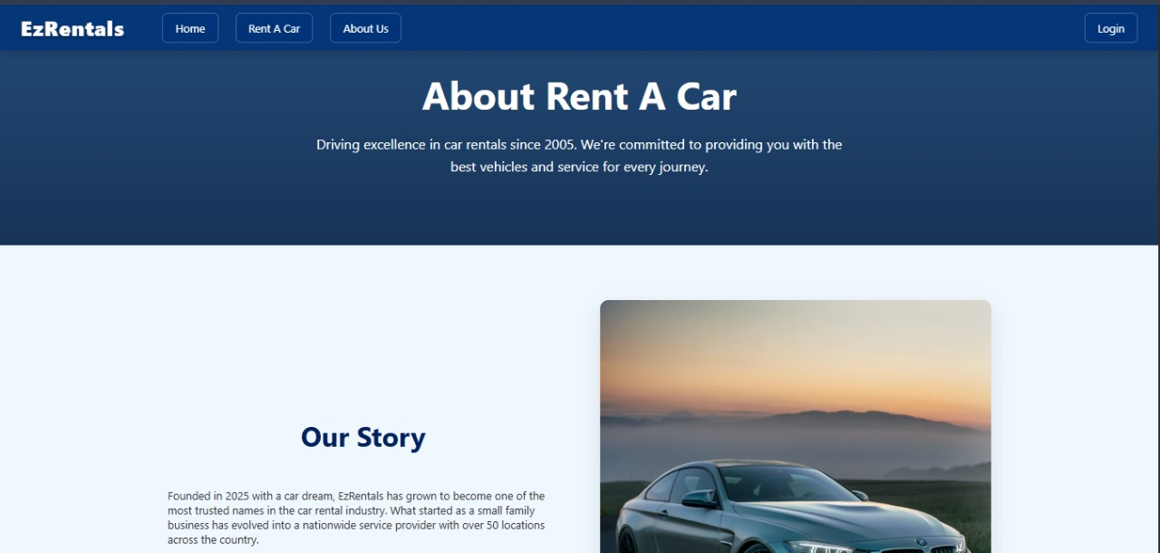

Experimental Results
This section outlines the specific technical hurdles we encountered and how we resolved them.
Frustration 1: The "Date Conversion" Error
- Issue: Whenever we tried to save a reservation, the system crashed with "Conversion failed when converting date and/or time from character string." This was incredibly frustrating because the date looked correct in the text box.
- Solution: We discovered that passing dates as strings relies on the server's region settings. We solved this by refactoring our code to use DateTime.TryParse in C# to validate the input first, and then passing the parameter to SQL using SqlDbType.DateTime explicitly. This type-safe approach eliminated the ambiguity.
Frustration 2: The "Missing Parameter" Crash
- Issue: When adding the payment logic, we got an error about "too many arguments." We realized our SQL Stored Procedure sp_BookReservation did not accept an @Amount parameter, but our C# code was sending it.
- Solution: We had to ALTER the SQL procedure to accept the new @Amount and an @ReservationID OUTPUT parameter. This taught us the importance of keeping the Database signature and Application code in perfect sync.
Frustration 3: Broken Images
- Issue: Images uploaded appeared as broken icons.
- Solution: We realized the database was storing the column name CarImage but our code was trying to read Carimages (the folder name). We corrected the binding to <%# ResolveUrl(Eval("CarImage").ToString()) %> to correctly parse the tilde (~) path.
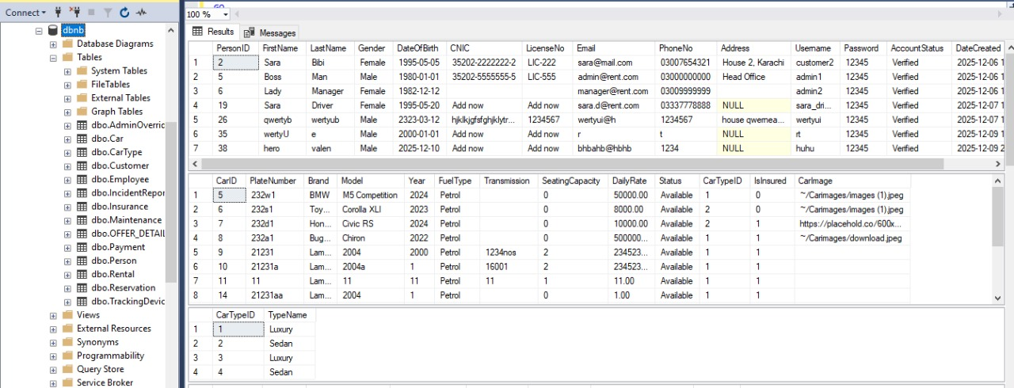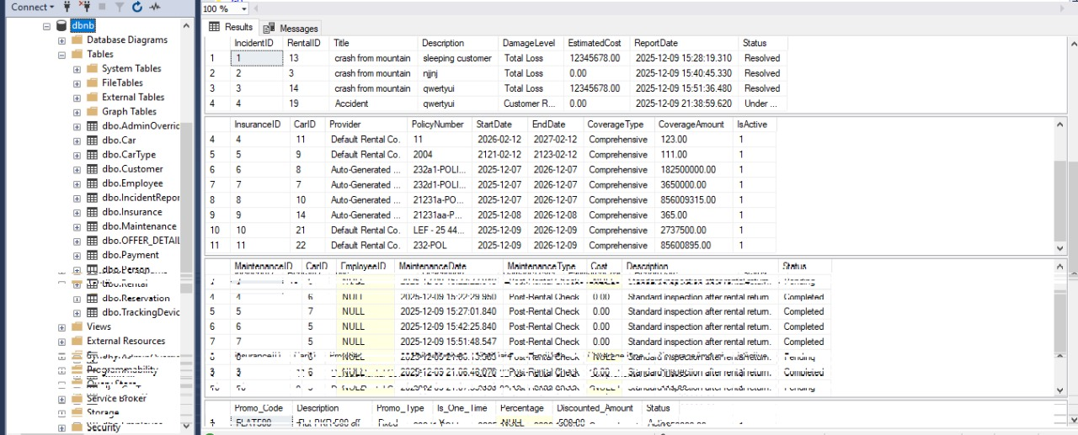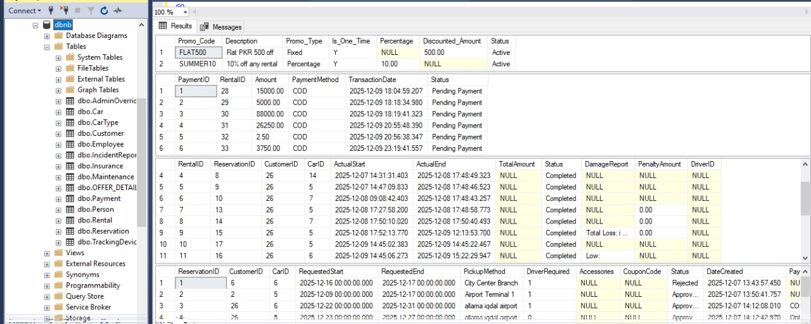
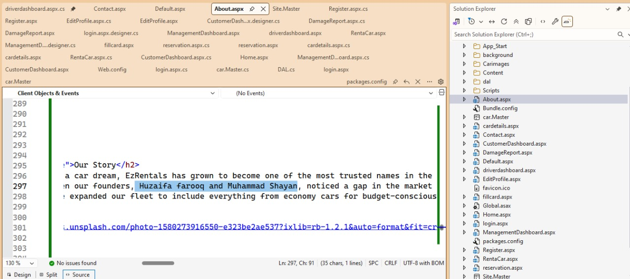

Performance Analysis
We analyzed the performance of the application, specifically focusing on the "Rent A Car" search page.
Initial Approach vs. Optimized Approach:
Initially, we loaded all cars into C# memory and filtered them using a foreach loop. As we added dummy data, we realized this would be slow with thousands of records.
- The Fix: We moved the filtering logic to the database layer by creating sp_FilterAvailableCars. This procedure accepts parameters for @SearchTerm, @Category, and @SortBy.
- Result: The database now performs the filtering before sending data over the network. This reduced the data payload size and significantly improved page load times.
Connection Management:
We utilized the using statement for all SqlConnection and SqlCommand objects. This ensures that database connections are closed and disposed of immediately after use, preventing connection leaks that could crash the server under load.

Future Scope (Optional)

While the current system is robust, there are several avenues for future enhancement.
- Payment Gateway Integration: Currently, the "Online Payment" option is a simulation. In the future, we plan to integrate APIs like Stripe or JazzCash to process real credit card transactions securely.
- GPS Integration: We have a TrackingDevice table in our schema. The future scope includes linking this to a real-time Maps API (like Google Maps) to allow Admins to see the live location of their rental fleet on the Dashboard.
- Mobile Application: A React Native or Flutter mobile app for Drivers would be beneficial. It would allow them to see their assigned trips and mark "Pick Up" and "Drop Off" times directly from their phones, automatically updating the central database.

Social and Cultural Implications (Optional)

The deployment of the Car Rental Management System has broader implications beyond just technical efficiency.
- Formalization of the Economy: By moving from cash and paper to digital records, the system encourages transparency. Every transaction is recorded, which helps in tax compliance and financial auditing.
- Employment Standards: The system formally recognizes "Drivers" and "Maintenance Crew" as entities in the system. This helps in tracking their work history and performance, potentially leading to better fair-wage practices based on recorded hours and trips.
- Environmental Impact: By digitizing rental agreements, receipts, and inspection logs, the system drastically reduces paper waste. This aligns with modern cultural shifts towards environmentally conscious business practices.
- Trust: In our culture, disputes over car damage are common. By having a digital IncidentReport system with logs, we increase trust between the renter and the agency.

Conclusion
The development of the Car Rental Management System was a challenging but rewarding journey. We started with a fragmented set of requirements and disjointed code snippets. Through the process, we faced significant technical frustrations—specifically regarding database schema overlaps, date format conflicts between C# and SQL, and frontend image rendering issues.
However, by adopting a systematic approach—unifying our SQL script into a single file, enforcing strict type checking in C#, and implementing professional Stored Procedures for logic—we successfully built a stable, functioning application. The final system not only meets the functional requirements of booking and inventory management but also solves the critical business problems of data redundancy and calculation errors. This project stands as a testament to the power of integrating a strong database backend with a dynamic web frontend to solve real-world business problems.

References

- Microsoft Documentation. (2024). ASP.NET Web Forms & ADO.NET Connection Pooling.
- Google AI. By Google
- Open AI. With GPT
- Beighley, L. (2022). Head First SQL: Your Brain on SQL. O'Reilly Media.
- Freeman, A. (2023). Pro ASP.NET Core 6. Apress.
- W3Schools. (2024). CSS Grid Layout Module.
- StackOverflow Community. (2025). Discussions on SQL Date Conversions and Stored Procedure Parameters.

Range of Complex Engineering Activity
EA1: Range of  resources  EA2: Level of interaction  EA3: Innovation  EA4: Consequences for society and  environment EA5: Familiarity | - EA1: Range of resources -- The design involves the use of diverse resources, such as, money, equipment, information, and technology.  - EA2: Level of Interaction – The design requires resolution of various problems arising from interactions between wide-ranging or conflicting technical or other issues.  - EA3: Innovation – The design addresses sustainability and reduces cost requiring creative use of engineering principles and research-based knowledge in novel ways.  - EA5: Familiarity – The design activity emphasizes the integration of existing knowledge and tools (or familiar solutions) with new or unfamiliar challenges
 | Rubrics |  | LLOs | Marks
 | Explains the design process including engagement of resources clearly | EA1 | LLO3
 | Demonstrate the final design clearly with all supporting information | EA1,  EA5 | LLO4
 | Demonstrate how innovation has been used in design to resolve conflicting requirements including the impact on society and environment | EA2, EA3 | LLO4
 | Prepares a report which explain the design process including engagement of resources clearly, and is free from grammatical errors. | EA1 | LLO3

